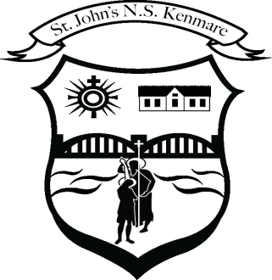
St. John’s N.S., Kenmare
Bunscoil Eoin Naofa, An Neidín
Tel: 064-6642598 / 064-664230
Email info@stjohnskenmare.ie
Web: www.stjohnskenmare.ie

Agreed Report February 12th 2024

- Fr. Hayes & the board said the opening prayer.
- Correspondence / Condolence: The board offered condolence to those recently bereaved in our school community. Letter from St. Senan’s Education Office with schedule of training events for new Board’s of Management.
- Ethos: Fr. Hayes led the board’s discussion on Ethos and gave an overview of where Catholic Education in Ireland is currently at.
It was also agreed to collectively examine the CPSMA document on Catholic Schools.
- Positions on Board of Management:
Treasurer: Maggie O’Donoghue
Recording Secretary: Barry O'Leary
Health & Safety Officer: John Sweeney
- Principal’s Report:
-Curriculum Progress: All teachers and classes are busy since our return to school after the Christmas holidays as they work through the curriculum content.
-Heritage in Schools Programme: Archaeologist Francesca Callaghan visited the school on January 22nd & 23rd and delivered workshops to pupils from 3rd to 6th class.
-School Self Evaluation Plan: The focus of our School Self-Evaluation Plan this year is ‘self-assessment skills’. The plan will be finalised and implemented this term.
-Policies Under Review Term Two: We are currently reviewing the school’s anti-bullying policy and code of behaviour as part of the requirement to review annually. We are also required to review our complaints procedure as the new standardised procedure is in effect since January 1st 2024.

