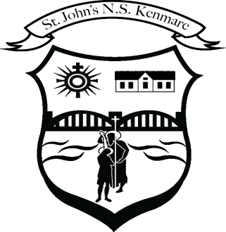
St. John’s N.S., Kenmare
Bunscoil Eoin Naofa, An Neidín
Tel: 064-6642598 / 064-664230
Email info@stjohnskenmare.ie
Web: www.stjohnskenmare.ie

Linking Self-Assessment Plan to Looking at Our School 2022: A Quality Framework for Primary Schools and Special Schools

- Learning and Teaching

Domain Two: Learner Experiences

Standard | Statements of Effective Practice | Statement of Highly Effective Practice
Pupils reflect on their progress as learners and develop a sense of ownership of and responsibility for their learning | Pupils assess their progress and are aware of their strengths and areas for development as learners. | Pupils assess their progress realistically and can describe their strengths and areas for development as learners.
 | Pupils take pride in their learning and follow the guidance they receive to improve it. | Pupils have a sense of ownership of their learning, take pride in it, and take responsibility for improving it.
 | Pupils reflect on their behaviour and attitude to learning, and are able to contribute to setting meaningful goals for themselves. | Pupils reflect on their behaviour and attitude to learning, and are able to set meaningful personal goals as a result of their reflection.

Domain Three: Teachers’ Individual Practice

Standard | Statements of Effective Practice | Statement of Highly Effective Practice
The teacher selects and uses preparation and assessment practices that progress pupils’ learning | Teachers share success criteria with pupils so that they can assess their own learning through self-assessment and peer assessment. | Teachers share and co-create success criteria with pupils so that they can assess their own learning through self-assessment and peer assessment, and identify areas for improvement and strategies to achieve improvement.

