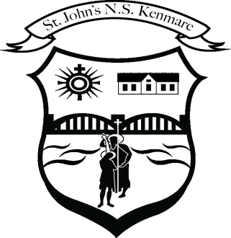
St. John’s N.S., Kenmare
Bunscoil Eoin Naofa, An Neidín
Tel: 064-6642598 / 064-664230
Email info@stjohnskenmare.ie
Web: www.stjohnskenmare.ie

Aims

- Cultivating a Positive Learning Environment: Foster a classroom culture where self-assessment is embraced, encouraging a positive attitude towards personal growth and improvement.
- Promoting Ownership of Learning: Empower students from Junior Infants to Second Class to take an active role in their education by developing the ability to assess and reflect on their own class work.
- Building Self-Awareness and Emotional Intelligence: Introduce young learners to the concept of self-awareness, emotions, and personal achievements, contributing to the development of their emotional intelligence.
- Instilling a Growth Mindset: Encourage a growth mindset by emphasizing that improvement is achievable through effort, practice, and setting realistic goals.
- Enhancing Peer Collaboration: Integrate activities that promote peer discussions, sharing achievements, and supporting each other's goals, fostering a sense of community within the classroom.
- Aligning with Curriculum Goals: Integrate self-assessment seamlessly into the existing curriculum, ensuring that it complements subject-specific learning objectives and activities.
- Encouraging Lifelong Learning Habits: Lay the foundation for a lifelong habit of self-reflection and self-improvement, providing students with essential skills for continuous learning and adaptability.
- Creating a Supportive Feedback Loop: Establish a positive feedback loop where teacher observations, peer assessments, and self-evaluations contribute to a supportive learning environment that recognizes and celebrates individual progress.
- Aligning with Educational Trends: Address current educational trends that emphasize student-centered learning, individualized progress tracking, and the development of 21st-century skills such as critical thinking and self-regulation.

