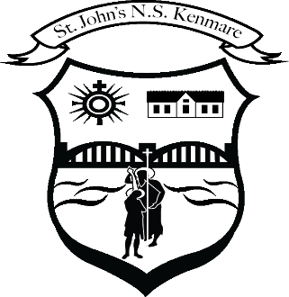
St. John’s N.S. Kenmare
Bunscoil Eoin Naofa An Neidín
Tel: 064-6642598 / 064-6642300
e-mail: info@stjohnskenmare.ie
web: www.stjohnskenmare.ie

St. John’s N.S. Kenmare
ANNUAL ADMISSION NOTICE
in respect of admissions to the 2024/2025 school year

Admission Policy and Application Form
A copy of the school’s Admission Policy and the Application Form for Admission for the 2024/2025 is available as follows: –
To download at: www.stjohnskenmare.ie
On request: By emailing info@stjohnskenmare.ie or writing to: St. John’s N.S., Railway Road, Kenmare, Co. Kerry.

PART 1 - Admissions to the 2024/2025 school year

Application and Decision Dates for admission to 2024/2025 school year
The following are the dates applicable for admission to Junior Infants/First Year (delete as appropriate)

The school will commence accepting applications for admission on | Oct. 13th 2023
The school shall cease accepting applications for admission on | Jan 12th 2024
The date by which applicants will be notified of the decision on their application is | Feb. 23rd 2024
The period within which applicants must confirm acceptance of an offer of admission is | Mar. 8th 2024
*Failure to accept an offer within the prescribed period above may result in the offer being withdrawn

Note: the school will consider and issue decisions on late applications in accordance with the school’s admission policy.

Special Class Application and Decision Dates for admission to 2023/2024
The following are the dates applicable for admission to the school’s Special Class which caters for children with Autism Spectrum Disorder (ASD)
The school will commence accepting applications for admission to the special class on | Oct. 13th 2023
The school shall cease accepting applications for admission to the special class on | Jan 12th 2024
The date by which applicants will be notified of the decision on their application for admission to the special class is | Feb 23^{rd.}2024
The period within which applicants must confirm acceptance of an offer of admission is | March 8th 2024
*Failure to accept an offer within the prescribed period above may result in the offer being withdrawn

Number of places being made available in 2023/2024

The number of places being made available in Junior Infants is | 60
The number of places being made available in the special class which caters for children with Autism Spectrum Disorder (ASD) | 0

Signed: ____________________________________ Date: __________________

Chairperson of the Board of Management

