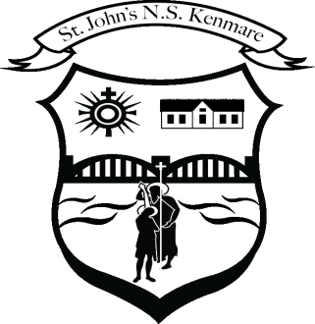
St. John’s N.S., Kenmare
Bunscoil Eoin Naofa, An Neidín
Tel: 064-6642598 / 064-664230
Email info@stjohnskenmare.ie
Web: www.stjohnskenmare.ie

Agreed Report 12/12/2023
1.Opening Prayer/ Minutes of previous meeting
The meeting began at 6pm. Fr. George Hayes said the opening prayer.

2. Patron’s Programme: All classes are engaging with the Patron’s Programme and lessons that are emailed from the diocese to us are disseminated to class teachers on a weekly basis. All classes begin and end each school day with a prayer.

3. First Holy Communion: Proposed date is Saturday May 13th 2022 at 10.30am.

4. Confirmation: Proposed Date and Time is Thursday March 2nd 2022 at 3.30pm.

5. Reading Buddies: Reading buddies has re-commenced and has been a success over the last three Friday's with students from younger and older classes reading to each other.

6. Gymnastics: Junior Infants to 2nd class have been engaged in gymnastics as part of the PE curriculum since the beginning of the school year. The senior side of the school will begin their programme in term two. An external coach is delivering these lessons which the children enjoy immensely.

7. Kerry Mental Wellbeing Fest: Our school participated in Kerry Mental Wellbeing Fest from 10th – 14th October 2022 and were one of a small number of primary schools in the county to do so. Children enjoyed and participated in a wide range of activities that week.

8. Cumann na mBunscoil: Our Cumman na mBunscoil team won the Urban 2 final in Austin Stack Park Tralee on October 18th against Scoil Eoin Balloonagh. The boys and girls who were part of the panel were a credit to themselves, their families and their school. Thanks to Mr. Morley and Mr. Hussey for their work with the group.

9. Student Council: The student council met as a group after the midterm break to discuss activities we wanted to implement in the school especially ones that were part of school life pre-covid.
The council decided on the re-introduction of reading buddies initiative and yard buddies. The council will meet again before the Christmas holidays. Particular mention to Mr. Morley for his work with the student council.

