Maths; 20th-24th April

The children are learning to record the story of 10 using the ten frame to demonstrate the different combinations that total 10.

Workbook page 87 and 88

Ten Green Bottles
Ten green bottles hanging on the wall, Ten green bottles hanging on the wall,
And if one green bottle should accidently fall, There’ll be nine green bottles hanging on the wall.
Nine green bottles hanging on the wall, Nine green bottles hanging on the wall,
And if one green bottle should accidently fall, There’ll be eight green bottles hanging on the wall.
(Continue until only one green bottle is left)
One green bottle hanging on the wall, One green bottle hanging on the wall,
And if that one green bottle should accidently fall, There’ll be no green bottles hanging on the wall. No green bottles hanging on the wall.

Ten in the Bed
There were ten in the bed
And the little one said ‘roll over, roll over’, So they all rolled over and one fell out.
There were nine in the bed
And the little one said ‘roll over, roll over’ So they all rolled over and one fell out.
(Continue until only one is left)
There was one in the bed and the little one said ‘Goodnight!’

Say the number rhymes with your child. Add simple actions to the number rhyme. Ask questions after each verse, e.g. How many bottles are on the wall? How many bottles fell off the wall? How many bottles are on the wall now? If there are seven bottles on the wall and three bottles on the ground, how many bottles are there altogether? Record the sums on paper e.g. 7 + 3 = 10.

Use 10 counters (cubes, pencils, crayons). Put them altogether. Say the number rhyme and take off the corresponding number of cubes, e.g. one falls off the bed so they take off one cube. Ask questions about the rhyme after each verse, e.g. How many children were in the bed? How many children fell out? How many children are in the bed now? If there are six children in the bed and four children on the floor, how many children are in the room altogether? Write corresponding sums on the paper, e.g. 6 + 4 = 10.

ten frame
The frame can be used for visual recognition of the components of number. This leads to the children being able to answer maths questions from their visual memory. For example, show them two red counters on the ten frame (for a second or two). How many more counters to make 10? Sample problems:
- Show three red counters. How many more to make 10?
- Show two red counters. How many more to make 10?
- Show one red counter. How many more to make 10?
- Show four red counters. How many more to make 10?
- Show five red counters. How many more to make 10?

  - Show 10 red counters. If I took away one, how many would be left?
  - Show 10 red counters. If I took away three, how many would be left?
  - Show 10 red counters. If I took away four, how many would be left?
  - Show 10 red counters. If I took away two, how many would be left?
  - Show 10 red counters. If I took away five, how many would be left?

  - Show 10 red counters. How many do I take away to make 10?
  - Show 10 red counters. How many do I take away to make 9?
  - Show 10 red counters. How many do I take away to make 8?
  - Show 10 red counters. How many do I take away to make 7?
  - Show 10 red counters. How many do I take away to make 6?
  - Show 10 red counters. How many do I take away to make 5?

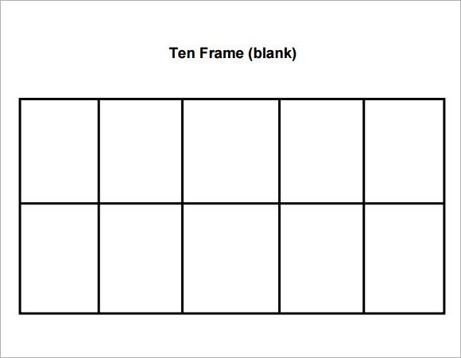

Maths: 27th April -1st May

Workbook pages 89-91

materials: Counters, paper plates, straws, markers.
Place 10 counters on the paper plate and use the straw to explore the different ways that the set of 10 can be partitioned. Record the sums on paper, e.g. 6 + 4 = 10.

materials: Counters (10 of two colours, e.g. 10 blue counters and 10 red counters per child), ten frames, crayons.
Use their counters and ten frames to illustrate the story of 10. Then record their answers on the extra ten frames.

materials: Counters, numeral 0–10 on flashcards (attached at end of document)
Place the cards face down on the table. They pick up 9 cards and identify which one is still face down. They use counters to show the missing numeral

materials: Ten frames, counters, dice.
Roll one dice and place the corresponding number of counters on their ten frame. The first child to reach 10 counters wins

How many?
materials: Cubes, bowls, cups.
Eestimate how many cubes it will take to fill the cup. Fill the cup with cubes. How many cubes did it take to fill the cup? Repeat with cubes and a bowl.

