Ms. Spillane 5th Class
Week 3: Monday 30th March– Friday 3rd April

Dear students and parents,
I hope you and your family are all keeping well.
Below you will find a timetable for this week’s school work. Similar to last week, the work is divided into each school day, Monday to Friday. This is a guide to help you approach the work given in class. I have included some more websites and links that you might find useful. Please note: click the underlined blue words to get to links.
Take care and enjoy the Easter holidays,
Ms. Spillane

Included here:
- Weekly timetable
- Other work
- Project work
- Links to our class textbooks + useful websites
- Photos of worksheet given out in class

- Weekly timetable
Print these sheets if possible and tick off work as you go along.
Day/ Lá | School Work/ Obair Scoile | □
Overview of week:
Gaeilge: An Seanbhean Bhocht
English: War Horse/ Procedural Writing
Maths: Length
Geography/ Science: The Amazing Human Body (The digestive system)
History: Leonardo da Vinci
Religion: Easter
Art: Leonardo da Vinci / Easter
P.E.: Daily kids’ session with Joe Wicks available on YouTube

Monday/  Dé Luain  30/3/20 | Gaeilge:  - Seo Leat:  Read pgs. 82-83 and answer question A on pg. 84  English:  - English in Practice: Day 100  - Writing Sheets: Procedural writing sheet pg. 62- 63  Read pg. 62 and answer pg. 63  - War Horse: Read chapter 17 and answer any three questions  Maths:  - Operation Maths: Chapter 14 pg. 120  Answer questions 1, 2 and complete work it out problems  Please write the answers for talk time (question 1)  - Mental Maths: Wk. 28 Day 1 and problem solving  - Optional: Work through Maths sheets on length  Geography + Science:  - Small World Unit 7: The Amazing Body  Read pgs. 38-42 and answer the questions on pgs. 39 and 42  P.E.:  - Check out Joe Wick’s daily kids’ workout here | □  □  □  □  □  □  □  □  □  □
Tuesday/  Dé Máirt  31/3/20 | Gaeilge:  - Seo Leat:  Pg. 84 C: Write out sentences using the correct verb  Pg. 85 D: Bhí an tseanbhean trína chéile mar chaill sí an léarscáil. = The old lady was confused/ flustered because she lost the map.  Connect and write out the sentences and write two new ones  - L.S.B. x 1 side  (available in link below if you do not have a card)  English:  - English in Practice: Day 101  - Writing Sheets: Procedural writing sheet pg. 64  Use the frame to write the instructions. Please do not write out a draft at this point.  - War Horse: Read chapter 18 and answer any three questions  Maths:  - Operation Maths: Chapter 14 pg. 121-122  Answer questions 1,2,3,4 and complete work it out problems  - Mental Maths: Wk. 28 Day 2 and problem solving  - Optional: Work through Maths sheets on length  Geography/ Science:  - Small World Unit 7: The Amazing Human Body  Answer sheet pg. 14  Optional extra: Complete either of the design and make tasks on pg. 42  Religion:  - Easter:  Read through The Story of Easter PowerPoint.  P.E.:  - Check out Joe Wick’s daily kids’ workout here | □  □  □  □  □  □  □  □  □  □  □  □  □
Wednesday/  Dé Ceadaoin  1/4/20 | Gaeilge:  - Seo Leat:  Pg. 85:  Caithfidh mé = I must  Write out the sentences.  Táim préachta leis an bhfuacht = I’m frozen with the cold.  Draw a picture to illustrate the phrase.  English:  - English in Practice: Day 102  - Writing Sheets: Procedural writing sheets pgs. 66-67  Read pg. 66 and answer pg. 67  - War Horse: Read chapter 19 and answer any three questions  - Comprehension card x 1  Maths:  - Operation Maths: Chapter 14 pg. 122-123  Answer questions 1, 3 and complete work it out problems. Please write the answers for talk time (question 1).  - Mental Maths: Wk. 28 Day 3 and problem solving  - Optional: Work through Maths sheets on length  History:  - Small World Unit 4: Leonardo da Vinci  Read pgs. 18-20 and answer any two sections from A-E on pg. 21  Art:  - Easter card templates  Print or copy the templates  P.E.:  - Check out Joe Wick’s daily kids’ workout here | □  □  □  □  □  □  □  □  □  □  □  □  □
Thursday/  Déardaoin  2/4/20 | Gaeilge:  - Seo Leat:  Pg. 86 question E 1-11  Write out the sentences using the correct verb tense  - L.S.B. x 1 side  (available in link below if you do not have a card)  English:  - English in Practice: Day 103  - Writing Sheets: Procedural writing sheets pg. 68  Write out a recipe using the frame. There is no need to write a draft at this point.  - War Horse: Read chapter 20 and answer any three questions  Maths:  - Operation Maths: Chapter 14 pgs. 124 – 125  Answer questions 1,2 and complete work it out problems  - Mental Maths: Wk. 28 Day 4 and problem solving  - Optional: Work through Maths sheets on length  History:  - Small World Unit 4: Leonardo da Vinci  Complete sheets pgs. 10-11  Religion:  - ‘The Last Supper’ by Leonardo da Vinci  Complete the art appreciation activities  P.E.:  - Check out Joe Wick’s daily kids’ workout here | □  □  □  □  □  □  □  □  □  □  □
Friday/  Dé hAoine  27/3/20 | Gaeilge:  - Seo Leat:  Pg. 86 question E  Cuir isteach an focal ceart.  (Put in the correct word.)  Pg. 87 question G  Athscríobh na habairtí  (Rewrite the sentences in the correct order.)  English:  - English in Practice: Day 104  - Writing Sheets: Procedural writing sheets pgs. 70/ 72  Read pg. 70 and write instructions for a trick in the frame on pg. 72. There is no need to write a draft at this point.  - War Horse: Read chapter 21 and answer any three questions  Maths:  - Operation Maths: Chapter 14 pg. 125  If possible, complete question 4  - Mental Maths Wk. 28 Friday test  - Read the Vitruvian Man PowerPoint and complete pg. 2 of the Vitruvian Man Maths exercise.  - Optional: Work through Maths sheets on length  Art:  - ‘Mona Lisa’ by Leonardo da Vinci art appreciation activity  Complete the activities on ‘Mona Lisa’  P.E.:  - Check out Joe Wick’s daily kids’ workout here | □  □  □  □  □  □  □  □  □  □  □  □
2. Other work

Other activities you could complete if you are finished your daily work:
- Jolly Grammar: Complete any incomplete pages up to week 25
- Maths sheets on fractions, decimal, percentages and length
- Read a variety of texts
- Watch educational programmes on RTÉ and TG4
- Project work as detailed below
- Pobble 365
Use the daily picture on Pobble 365 and do some of the activities underneath i.e. Story starter, sentence challenge, sick sentences, question time or perfect picture.
- Complete a daily quiz on seomra ranga
3. Project
Optional project work on the theme of Space to be completed over a two-week period
- Read through PowerPoints ‘Amazing Astronauts’ and ‘Apollo 11- Moon Landing’ attached. (Please don’t worry if you don’t have access to PowerPoint and can’t do this.)
- In your copy, put the title ‘Our Solar System’ on the top of the page. Using the ‘Solar System Fact Cards’ attached, answer the eight questions below in your copy.

Solar System Fact Hunt - Questions to answer in copy
- Which planet orbits closest to the Sun?
- Which planet has the highest maximum temperature?
- Which planet’s atmosphere contains the highest percentage of carbon dioxide?
- How much larger is Earth than Mars?
- Which planet has the shortest day?
- Which planets are made of gas?
- Which planet has the most moons?
- What is the Earth’s atmosphere made mostly of?

- Underneath the answers to the eight questions about the Solar System, draw a picture of the eight planets in our Solar System and colour them in. Don’t forget to include the Sun.

- There is a ‘Space Quiz PowerPoint’ attached also that you might like to do.

- You can pick any aspect of space and do a project on it over the next two weeks. You can choose to do your project in any one of the following ways:

    - PowerPoint
    - Poster with facts and images
    - An art project

- Links our class textbooks + useful websites
The websites below are offering access to our class textbooks. If these do not open please follow the website guidelines for student access to each of the specific book titles.
Our text books
- Edco
Operation Maths 5: (Edco Digital)
Click the link below and go to Maths and Operation Maths 5
https://www.edcolearning.ie/
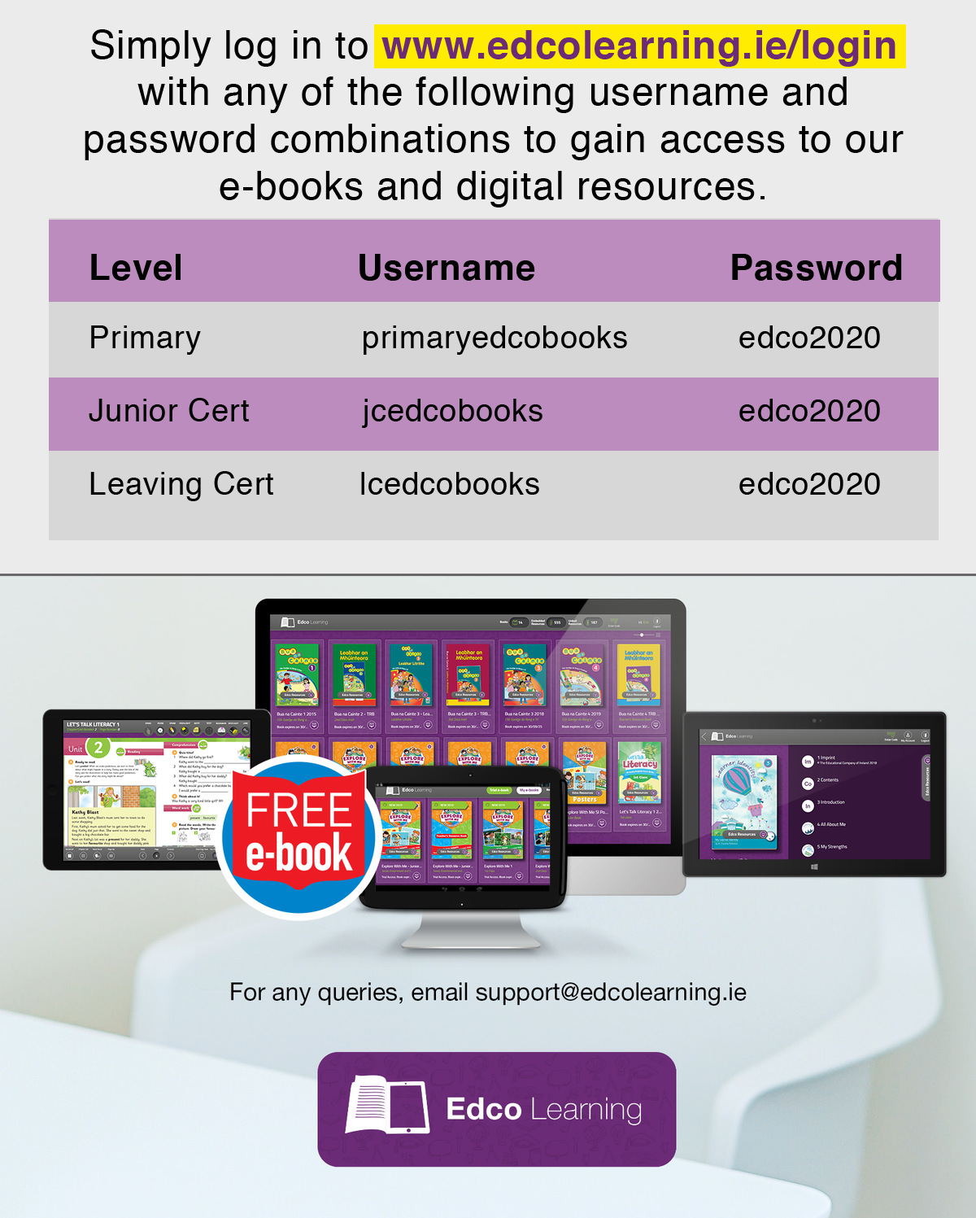
- CJ Fallon
Figure it Out 5: (CJ Fallon)
Seo Leat: (CJ Fallon)
Léigh sa Bhaile: (CJ Fallon)
Small World Geography + Science and History: (CJ Fallon)
Click the link below and go to the individual subjects and the books will be there.
https://www.cjfallon.ie/books/primary/

Other websites and links
- Gaeilge
Teanglann is an online Irish dictionary
- P.E.
Try Joe Wick’s workout here
- Twinkl has free resources available on all subjects
Go to www.twinkl.ie/offer and enter the code IRLTWINKLHELPS
- Reading
Listen to audio books here:
https://stories.audible.com/discovery
https://pernillesripp.com/2020/03/14/picture-books-read-aloud-videos-for-lesson-use/
Listen to David Walliams
- World Book Encyclopaedia

- Educational programmes

- Photos of worksheets given out in class
Photos of worksheets

