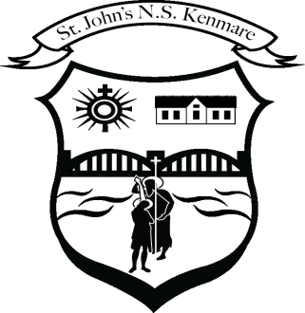
St. John’s N.S., Kenmare
Bunscoil Eoin Naofa, An Neidín
Tel: 064-6642598 / 064-664230
Email info@stjohnskenmare.ie
Web: www.stjohnskenmare.ie

Dear Parents / Guardians,

Just a short note to inform you that we are commencing our School Self-Evaluation Plan for this school year.
The focus will be on pupil’s self-assessment skills.
Over the next number of weeks, the pupils will be intentionally engaged in a variety of age appropriate, cross curricular self-assessment activities each school day.
After a period of time data will be gathered to help us to evaluate the efficacy of the plan.
Self- assessment capacity of pupils was highlighted as a potential area of weakness in last year’s school survey.
Choosing self-assessment skills as our focus provides a valuable opportunity for our students to develop a deeper understanding of their own learning journey. By nurturing the ability to evaluate their own class work, we empower them to take ownership of their progress, foster a growth mindset, and cultivate essential skills for lifelong learning. This emphasis on self-awareness and reflection aligns with current educational trends and aims to instill a sense of responsibility and autonomy in our young learners.

Mr. Barry O'Leary
Principal

