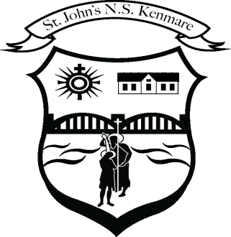
St. John’s N.S., Kenmare
Bunscoil Eoin Naofa, An Neidín
Tel: 064-6642598 / 064-664230
Email info@stjohnskenmare.ie
Web: www.stjohnskenmare.ie

Agreed Report 07/06/2023
1.Opening Prayer/ Minutes of previous meeting
The meeting began at 6pm. The board said the opening prayer.

2. Patron’s Programme: All classes are engaging with the Patron’s Programme and lessons that are emailed from the diocese to us are disseminated to class teachers on a weekly basis. All classes begin and end each school day with a prayer.

3. Month of May: Our display board was dedicated to Mary for the month of May. Throughout the month all classes were encouraged to put a May alter in place in their classrooms and children brought flowers to decorate the alter in their classroom.

4. Cumann na mBunscoil Girls: Our girls team had an excellent run through the Urban Division 2 grade of Cumann na mBunscoil and lost narrowly to Scoil Eoin Balloonagh in the Co. Final in Austin Stack Park on May 23rd.

5. Primary Basketball Competition: We entered two boys teams and two girls teams in a basketball competition which was run over the past number of weeks in Presentation Gym Killarney. Our participating pupils had plenty game time and good exposure to the game which they very much enjoyed. Particular mention to Ms. Browne for taking the lead role in organising.

6. Exploration Dome: The Exploration Dome, a 3D virtaul experiene of space and the oceans visited our school from May 22nd-24th and was throughly enjoyed by all pupils and staff.

7. Active Week/ Sports Day: Is taking place this week and pupils and staff are enjoying the activities. Particular thanks to our active week committee who did an excellent job in organising activities for the week.

8. School Tours: First Class (Crag Caves) Second Class ( Aura Sports & Leisure) and Sixth Class ( Mardyke) have had their school tours to date.

9. Student Council & Anti-Bullying: Mr. O’Leary discussed some important elements of Cinéaltas our student council on two occasions since our last board of management meeting. Members of our student council will speak to all classes in our school about the importance of Cinéaltas, as well as our own Anti-Bullying Policy and Code of Behaviour.

