# NEWSLETTER – February 2022



**St. John’s N.S. Kenmare**

**Bunscoil Eoin Naofa An Neidín**

**Tel: 064-6642598 / 064-6642300**

**e-mail:** [**info@stjohnskenmare.ie**](mailto:info@stjohnskenmare.ie)

**web: www.stjohnskenmare.ie**

**Introduction:**

Welcome to the St. John’s National School Newsletter. We are delighted with the return of this termly resource as an informative tool for families. We are pleased with the re-introduction of many initiatives as well as some new projects and look forward to positive times ahead for our school community.

**Upcoming School Closures:**

Closed: Thursday 17th & Friday 18th March for St. Patrick’s Day and Public

Holiday.

Closing: Friday, 8th April at **12 noon** – Easter Holidays

Re-opening: Monday, 25th April at 9.20 a.m.

Closed: Monday, 2nd and Tuesday 3rd May – Public Holiday & School Holiday.

Closed: Monday, 6th June – Public Holiday

Closing: Friday, 24th June at **12 noon** – Summer Holidays

**Sacraments of First Confession, Holy Communion and Confirmation:**

Pupils from Sixth Class will receive the Sacrament of Confirmation on Tuesday, 29th March.

Mass at 11.00a.m. for the pupils in Mr. Morley’s 6th Class.

Mass at 1.30p.m. for the pupils in Ms. Healy’s 6th Class.

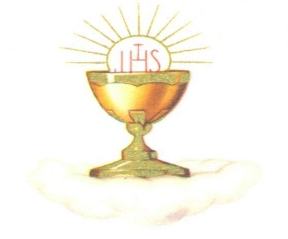At present pupils are taking part in the *“You Shall Be My Witnesses*” programme in preparation for Confirmation.

Pupils from Second Class will receive the Sacrament of First Confession on 15th March at 1p.m. The Sacrament of First Holy Communion will take place on Saturday, May 7th at 10.30a.m. in Holy Cross Church.

**Cumann na mBunscoil:**

St. John’s are again gearing up for the annual Cumann na mBunscoil football competition taking place in March. Our boys and girls are getting in as much practice as possible of the skills and training every week in preparation for the games that will take place at the end of March. The boys competition will take place on March 23rd and the girls a day later on March 24th. Go n-éirí an t-ádh libh buachaillí agus cailíní!

**Incredible Edibles:**

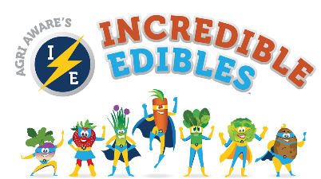Incredible Edibles is a healthy eating project for Primary Schools. The aim of the project is to educate students about growing fruit and vegetables and to increase their knowledge of food origin and quality. We currently have five classes taking part in the initiative – Ms. Spillane’s 5th Class, Ms. O’Dwyer’s 4th Class, Ms. Shona O’Sullivan’s 3rd Class, Ms. Doyle’s 1st Class and Class Neidín.

**Green-Schools Global Citizenship – Marine Environment Theme:**

The boys and girls at St. John’s are currently working on their 8th Green-Schools’ theme, Global Citizenship – Marine Environment. This theme focuses on raising awareness of marine eco-systems and the work being done to save them. We hope to be awarded our eighth green flag in April. We will also be taking part in the National Spring Clean in April in association with An Taisce. As well as that, the school will participate in SuperValu’s ‘Save the Bees’ campaign which runs in conjunction with he National Biodiversity Data Centre and the All-Ireland Pollinator Plan to help Save the Bees. Students and their families are asked to collect Save the Bees tokens from SuperValu and bring to school up until the 10th May. As part of the campaign, we have been provided with seeds which we will plant in the coming weeks to create a bee-friendly garden.

**Seachtain na Gaeilge:**

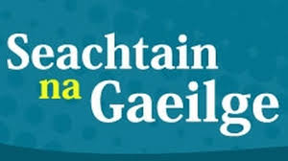Seachtain na Gaeilge takes place from 1st to 17th March and all the children have been making an extra special effort with their Gaeilge! The pupils are involved in a number of school initiatives such as Gaeilgeoir na Seachtaine, Comórtas Scríbhneoireacht, Tráth na gCéist agus Lá Glas. It’s important for the children to hear Gaeilge as a spoken language both in school and at home, using cúpla focal at home every day would be very beneficial to the children. ‘Beatha teanga í a labhairt’!

**Dia duit** – Hello, **Conas atá tú?** – How are you?, **Aon scéal?** – Any news?,

**Le do thoil** – Please, **Go raibh maith agat** – Thank you, **Slán** – Goodbye.

**Lá Glas – Green Day:**

On Wednesday, 16th March, we will take part in a non-uniform day to mark the end of Seachtain na Gaeilge in the lead up to St. Patrick’s Day. Pupils are invited to wear something green if they wish and will take part in activities to promote Irish on that day.

**Spanish Students**

In February, we welcomed two students from Cordoba and Madrid in Spain on international placement from Cardenal Cisneros University in Madrid and Magisterio Sagrado Corazón University in Córdoba. They came here to improve their English and to share and exchange teaching methodologies with Irish Teachers. In Spain, many teachers specialize in one or two subjects and luckily for our pupils, both teachers named Javier specialize in P.E. and took charge of teaching P.E. to all classes. When they return to Spain, they will continue in their teacher training to gain their qualification in Primary Teaching. Both trainees are very impressed with the very high quality of teaching and learning and the methodologies used in Ireland such as team teaching and station teaching. They are also very impressed with the friendliness and attention of the pupils they have worked with. We would like to thank them for sharing their expertise with us and wish them every success in their teaching careers.

**Amber Flag Initiative:**

The Pieta House Amber Flag Initiative recognizes the individual efforts of schools that support mental well-being. We are currently working on creating a positive, safe and healthy attitude towards mental health and well-being with a variety of activities taking place. One of these activities is the introduction of our ‘Wellbeing Wednesday’ campaign on the first Wednesday of every month where we engage in fun activities to promote positive mental health. We have also set up a buddy system in the yard to support friendships.

**Daffodil Day:**

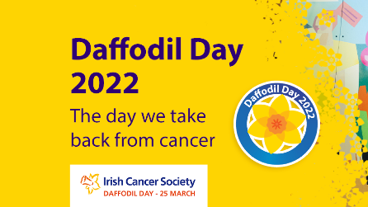This year, Daffodil Day takes place on Friday, 25th March. St. John’s will take part in a non-uniform day to support the Irish Cancer Society on their 35th Anniversary fundraiser and students are invited to wear something yellow if they wish. We also ask for an optional donation of €2 from each child to support the initiative. Thank you.

**Workshop on Bullying and Cyber Bullying:**

On Wednesday, 16th March, 5th and 6th Classes will take part in a workshop on bullying and cyber bullying. Students will reflect on how face to face and online bullying differs from other forms of behaviour and understand how the importance of taking responsibility for their own behaviour towards others. They will also be taught strategies for coping with online bullying and will learn how to report face to face and online bullying they witness. The course is run by Anti-Bullying Services – a school-based support, dispute resolution and mediation service. For more information go to [www.antibullyingservices.ie](http://www.antibullyingservices.ie).

**Music:**

St. John’s are delighted to welcome Peggy Healy back this term for Music! Peggy will be working with all classes promoting the Music Curriculum strands of Listening and Responding, Performing and Composing. We are looking forward to developing creativity and expressing ideas and experiences through Music. Thanks Peggy!

**Parent’s Association Coffee Morning:**

St. John’s Parent’s Association will hold a Coffee Morning and Bake Sale in St. John’s on Friday, 1st April from 10a.m. to 1p.m. This is a fundraiser for the school. Money raised will go towards extra-curricular activities for the students. Please support this event by donating home baking and please attend on the morning to enjoy this community event. Everyone welcome! Pupils may want pocket money for the bake sale. Home baking can be dropped off at the back of the school on Friday morning from 9a.m. onwards. Please label cake boxes/trays with your name if you need them returned to you. We are very grateful to you all for your continued support. Many thanks!

**Gymnastics:**

We are delighted that Danny will recommence Gymnastics Classes for all Classes on Wednesdays in the coming term. Pupils will be looking forward to the ventures!

**Ten Years of St. John’s:**

This May, we mark the ten year anniversary of the opening of St. John’s National School. To commemorate this occasion, we will have a variety of events over the week from Monday 20th May to Friday 3rd June. Some of these events include a school Mass and Flag Day as well as the introduction of our new outdoor learning space which is a creative resource where students can explore education in a healthy, free and mood-lifting environment. Outdoor classrooms are proven to have social benefits including improvements in self-esteem and peer relationship building and fosters an enjoyment of learning in imaginative and expressive ways. This space will be named in memory of Ms. Ornaith Ní Loingsigh, our former Deputy Principal who sadly passed away in 2021. We hope that it will be a place of serenity and reflection for all.

**Swimming:**

Traditionally in St. John’s, 3rd Class would take part in Swimming Lessons in the Kenmare Bay Hotel in the final term of school. This year, 3rd, 4th and 5th Classes will get the opportunity to take part in swimming lessons because we are aware that the current 4th and 5th Classes missed out on the opportunity over the past two years. An exciting term ahead!

**Homework Club:**

Homework Club takes place in St. John’s N.S. Monday to Thursday from 3-4p.m. for pupils from 2nd to 6th Class. This is a calm, peaceful and supportive environment that allows children to complete their homework on a daily basis. Forms are available from the school office or contact Mr. Hussey for more information.

**School Tours:**

Teachers are currently in the process of organising School Tours for their classes for next term. We are delighted that we in a position to recommence with School Tours and we are delighted to have a range of fun activities to look forward to!

**Well Wishes:**

Congratulations to Ms. Carrie Spillane and her husband Padraig on their recent wedding. We wish them good health and happiness for the future. From all the staff and students in St. John’s National School, Kenmare.

We would also like to take this opportunity to extend our congratulations to Rosita McCarthy on her retirement from St. John’s at the end of March. Rosita has been an invaluable contribution to our staff over the past number of years. From all the staff and students, both past and present, Parent’s Association and Board of Management, we would like to wish her a very long and happy retirement.

Le gach dea ghuí,

______________________

Barry O’Leary

Principal