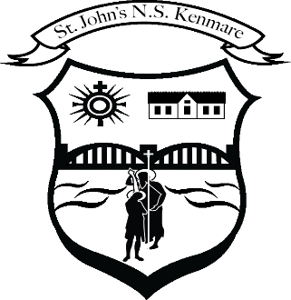
St. John’s N.S. Kenmare
Bunscoil Eoin Naofa An Neidín
Tel: 064-6642598 / 064-6642300
e-mail: info@stjohnskenmare.ie
web: www.stjohnskenmare.ie

St. John’s N.S. Kenmare
ANNUAL ADMISSION NOTICE
in respect of admissions to the 2021/2022 school year

Admission Policy and Application Form
A copy of the school’s Admission Policy and the Application Form for Admission for the [2021/2022] is available as follows: –
To download at: www.stjohnskenmare.ie
On request: By emailing info@stjohnskenmare.ie or writing to: St. John’s N.S., Railway Road, Kenmare, Co. Kerry.

PART 1 - Admissions to the 2021/2022 school year

Application and Decision Dates for admission to 2021/2022 school year
The following are the dates applicable for admission to Junior Infants/First Year (delete as appropriate)

The school will commence accepting applications for admission on | Oct. 5th 2020
The school shall cease accepting applications for admission on | Jan 15th 2021
The date by which applicants will be notified of the decision on their application is | Feb. 19th 2021
The period within which applicants must confirm acceptance of an offer of admission is | Mar. 5th 2021
*Failure to accept an offer within the prescribed period above may result in the offer being withdrawn

Note: the school will consider and issue decisions on late applications in accordance with the school’s admission policy.

Special Class Application and Decision Dates for admission to 2021/2022
The following are the dates applicable for admission to the school’s Special Class which caters for children with Autism Spectrum Disorder (ASD)
The school will commence accepting applications for admission to the special class on | Oct. 5th 2020
The school shall cease accepting applications for admission to the special class on | Jan 15th 2021
The date by which applicants will be notified of the decision on their application for admission to the special class is | Feb 19th 2021
The period within which applicants must confirm acceptance of an offer of admission is | March 5th 2021
*Failure to accept an offer within the prescribed period above may result in the offer being withdrawn

Number of places being made available in 2021/2022

The number of places being made available in junior infants is | 54
The number of residential places is (boarding schools only) | 0
The number of non-residential places is (boarding schools only) | 0
The number of places being made available in the special class which caters for children with Autism Spectrum Disorder (ASD) | 1

