

A Programme aimed at preparing 6th Class Pupils transferring to Secondary School
KDYS Transfer Programme
KDYS
www.kdys.ie
www.facebook.com/kdys

Session 1
Making the Transfer

Old school memories

New School expectations

Making the Transfer

Be prepared for:
Change – Excitement, Fear, Uncertainty.
Longer days.
New subjects.
Older students.
More than one teacher per day – up to 6 and sometimes up to 9.
That you change classes every 35-40 minutes / 1 hr – depend on the Secondary School you are attending.
Instead of your Class Teacher, you will have a Year Head, who you can link in with should you need help or support with anything.

Things that made the Transfer easier for Students previously:
Knowing older students in the school.
Knowing how to read a timetable.
Being the only year in school on the first day back in August.
Mentoring Programme – available in some Secondary Schools where older student take on the role of Mentoring 1st Years

Some more tips….
Utilise your locker – Get into the routine of organising your books / bag and accessing you lockers at the designate times which are usually before schools, during break/lunchtime and after school. Get used of using the combination lock (if applicable).
Take your homework diary to every class
Keep your money/valuables in your possession at all times/locked away securely
Be on time for class teachers won’t accept you being late after the first few days.
Wear your correct uniform – important to remember that you are easily identifiable with your school uniform especially if there are issues around behaviours.
Stay on top of homework - stick to deadlines, complete what you get on the night it’s assigned.
Stick within your designated areas – such as Junior & Senior Areas, Lunch Area etc.
Mobile Phones – be aware of the schools policies around these.
Become familiar with the Schools Support system – such as Chaplain. Guidance Counsellor, Care Team and Mentoring Supports.



Hand of Support - On each finger, write a source of support in school on each finger. What help might you need in school and who could you ask to help you?

Session 2
New Subjects / Time Tables

YOUR NEW SUBJECTS

B | W | S | R | U | L | A | L | H | X | T | K | E | X | D
H | U | N | R | S | D | C | W | L | I | A | I | H | V | W
O | N | S | E | E | Y | W | C | M | K | S | L | P | K | Q
M | O | F | I | Q | T | U | J | R | E | B | T | S | R | M
E | I | R | K | N | I | U | O | D | E | B | M | O | E | A
E | G | E | K | Q | E | W | P | H | V | A | J | T | R | N
C | I | N | J | V | D | S | K | M | T | Z | A | P | G | Y
O | L | C | R | O | J | Y | S | H | O | L | E | D | V | Y
N | E | H | O | F | H | K | S | S | W | C | T | P | E | C
O | R | W | H | S | I | R | I | O | T | R | L | V | S | T
M | B | U | N | N | M | P | R | I | A | U | B | K | G | C
I | B | W | F | I | N | K | Q | P | H | O | D | X | V | V
C | S | C | I | E | N | C | E | N | T | J | E | I | U | B
S | Y | H | P | A | R | G | O | E | G | M | B | T | E | R
K | J | Y | B | N | M | L | D | W | V | K | J | Z | K | S

ART BUSINESSSTUDIES COMPUTERS
CSPE FRENCH GEOGRAPHY
HISTORY HOMEECONOMICS IRISH
MATHS METALWORK RELIGION
SCIENCE SPHE WOODWORK
ART BUSINESS STUDIES COMPUTERS
CSPE FRENCH GEOGRAPHY
HISTORY HOMEECONOMICS IRISH
MATHS METALWORK RELIGION
SCIENCE SPHE WOODWORK
B | W | S | R | U | L | A | L | H | X | T | K | E | X | D
H | U | N | R | S | D | C | W | L | I | A | I | H | V | W
O | N | S | E | E | Y | W | C | M | K | S | L | P | K | Q
M | O | F | I | Q | T | U | J | R | E | B | T | S | R | M
E | I | R | K | N | I | U | O | D | E | B | M | O | E | A
E | G | E | K | Q | E | W | P | H | V | A | J | T | R | N
C | I | N | J | V | D | S | K | M | T | Z | A | P | G | Y
O | L | C | R | O | J | Y | S | H | O | L | E | D | V | Y
N | E | H | O | F | H | K | S | S | W | C | T | P | E | C
O | R | W | H | S | I | R | I | O | T | R | L | V | S | T
M | B | U | N | N | M | P | R | I | A | U | B | K | G | C
I | B | W | F | I | N | K | Q | P | H | O | D | X | V | V
C | S | C | I | E | N | C | E | N | T | J | E | I | U | B
S | Y | H | P | A | R | G | O | E | G | M | B | T | E | R
K | J | Y | B | N | M | L | D | W | V | K | J | Z | K | S

Time table
Time | Monday | Tuesday | Wednesday | Thursday | Friday
9.00 - 9.40 | French  CC R5 | Irish  KW R4 | Religion  SM RR | French  CC R5 | Maths  MH R6
9.40 – 10.15 | History  KW R4 | Maths  MH R6 | History  MMG R4 | Geography  SJ R5 | History  MMG R1
10.15 – 10.55 | Maths  MH R6 | Art  HS R6 | French  CC R5 | Business St  JOK R11 | Business St  JOK R11
10.55 – 11.10 | BREAK | BREAK | BREAK | BREAK | BREAK
11.10 – 11.50 | Business St  JOK R11 | French  CC R5 | Science  KD R1 | Art  HS AR | Irish  KW R4
11.50 – 12.25 | French  CC R5 | Business St  JOK R11 | Science  KD R1 | P.E.  JOK H | French  CC R5
12.25 – 13.05 | Art  HS AR | English  VG R2 | Geography  SJ R9 | P.E.  JOK H | French  CC R5
13.05 – 13.45 | Lunch | Lunch | Lunch | Lunch | Lunch
13.45 – 14.25 | English  VG R3 | French  CC R5 | Business St  JOK R11 | Irish  KW R4 | Religion  SM RR
14.25 – 15.05 | History  MMG R7 | Geography  SJ R9 | Maths  MH R6 | English  VG R8 | Art  VG R4
15.05 – 15.40 | C.S.P.E.  SG R7 | Religion  SM RR | Irish  KW R7 | Maths  MH R6 | English  VG R4
KW =Kate Walshe MH = Matt Hall JOK = O’Kelly
HS = Harry Sheehan VG = Veronica Grady
MMG = Mark Mcgrath SG = Sandra Gilligan SJ = Sam Jon es
SM = Sally Moore CC = Con Clarke KD =Keith Doyle

Study the timetable and answer the following questions:

Timetable Questions

What books do I need to have with me on Monday morning?

____________________________________________________________________________________

How long is the first break?

_________________________________________________________________________________

How long is the lunchtime?

____________________________________________________________________________________

Who Teaches Science?

____________________________________________________________________________________

What subjects does Harry Sheehan Teach?

____________________________________________________________________________________

What subjects have a double class period?

____________________________________________________________________________________

Which books will I need to get from my locker at lunch time on Wednesday?
________________________________________________________

Which room will I go to, after break, on Tuesday?

___________________________________________________________________________________

At what time will Sam Jones be in room 9 on Thursday?
________________________________________________________

What classes will I have first on Friday and where is it on?
____________________________________________________________________________________

Friendship
Session 3
FriendSHIP



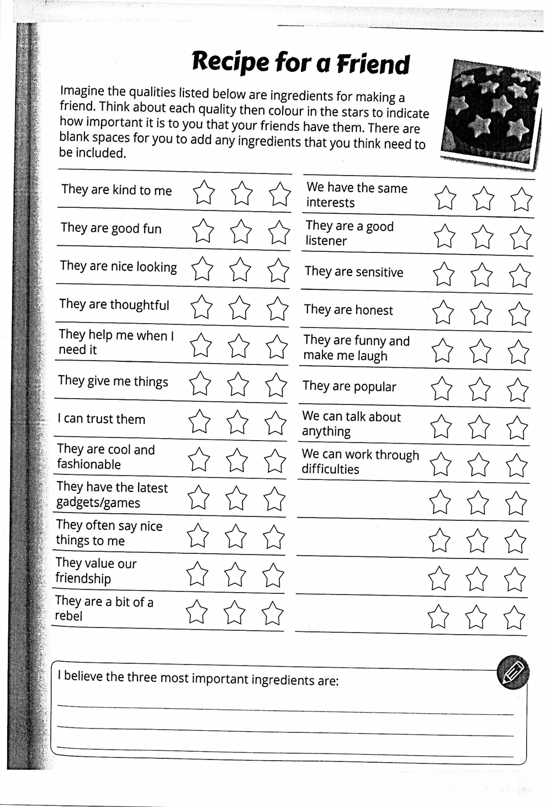

FRIENDS
What makes someone special enough to be called a friend?
_________________________________________________________________
__________________________________________________________________
_________________________________________________________________
How do I show my friends I care?
_________________________________________________________________
__________________________________________________________________
_________________________________________________________________
What are the things I like doing in the company of my friends?
_________________________________________________________________
__________________________________________________________________
_________________________________________________________________
What would it be like without friends?
__________________________________________________________________
_________________________________________________________________
__________________________________________________________________
How can you find a friend?
_________________________________________________________________
__________________________________________________________________
__________________________________________________________________

Resolving Arguments
• Keep calm
• Think positively
• Express your feelings, but don’t hurt anyone else’s feelings. Don’t blame, interrupt or call anyone names.
• Listen to and consider the other person’s reasons and feelings.
• Avoid saying “you should…” or “why didn’t you…”
• Focus on what you can do, not what you can’t or won’t do.

Strategies
• Give each other the chance to say what you think the problem is and try to agree on it.
• Take time to hear and understand each other’s explanations of what has made you angry or upset and why it matters.
• Try to appreciate each other’s point of view.
• Say what action you’d like to take and agree on a fair solution. For example if you are arguing over a computer game, agree times when each of you can play it or play it together.
• Try saying things like – “I’m listening to you, so please listen to me” or “what do you think about this”.

Points to Think About…
• Reflect on your own behaviour and how you form groups in order to make yourself feel secure.
• Try and value other people and consider their feelings and how you would feel if you were in their shoes.
•Being bullied may lead to bullying – the act of bullying can turn feelings of insecurity into power.
•Bullies pick on differences to undermine other children. But we are all different and should be valued equally.
•Remember the point of no return at which point you must tell an adult. The most important thing is you safety and the safety of others.

Session 4
Rules, Choices & Bullying

Rules within Secondary Schools vary slightly but are still along the same lines as those in Primary Schools and can be grouped in a number of categories including…
Uniforms - Bullying
Attendance, punctuality, Absenteeism
- Behaviours/Respect for all
Mobile phones
And obviously all the secondary schools have their own means of dealing with failure to comply with these and also their own punishments/sanctions for breaking the rules.

Brainstorm ‘What is Bullying?’

HANDOUT –‘I HAVE THE POWER’
BULLYING IS
repeated behaviour
never just fun
always hurtful
anti-social behaviour
BULLYING MAY BE
1. Physical- hitting, pushing, taking, or destroying, property
2. Verbal – name calling, sarcasm or spreading rumours
3. Emotional - creating an atmosphere of fear, humiliating or threatening another
4. Social - exclusion, teasing and jeering or intimidating.

The bully believes he is more powerful than you. You know you have a right to personal safety.
ACTION PLAN: If you are being bullied…..
Break the silence – tell someone. Talk to your friend, your parents, and your
favourite teacher, anyone you trust.
Report using the school procedure usually outlines in School Diary / Journal
Identify the times and places where bullying occurs.
Can you change your routine to avoid contact with the bully?
Ignore verbal abuse when possible.
Ask your friends to support you. Peer pressure may change the bully’s behaviour.
Keep a diary. Record the bullying incident/you’re response/something pleasant that you experienced on the same day.
Talk to the bully; explain that the behaviour to you is hurtful. Ask him/her to stop.
Be assertive, make eye contact, speak clearly, and walk with confidence.
If you are in danger, don’t fight to keep possessions.
Report any bullying that you experience or see.
You will be helping yourself and helping the bully face his/her problem and change his/her behaviour.

Transfer Programme
Session 5 – Cyber Safety
YOUR SHARING RELATIONSHIPS:
Who Would You Tell?

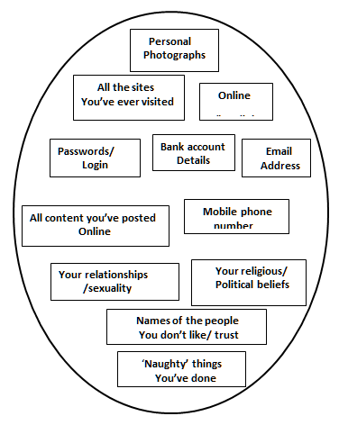
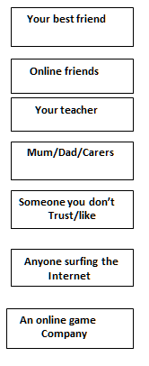

Warning-Sign Checklist: Am I Being Cyberbullied?

• I have received mean or threatening e-mail messages, text messages, or instant messages.
• Someone has posted mean or hurtful things about me online.
• Someone has forwarded my e-mails or text messages to another person without my permission.
• Someone has altered a picture of me online.
• Someone has taken pictures of me without my permission and posted them online.
• Someone has stolen my password and is sending messages or posting things and pretending to be me.
• Someone is excluding me from an online group.
• Someone has started an offensive blog about me.

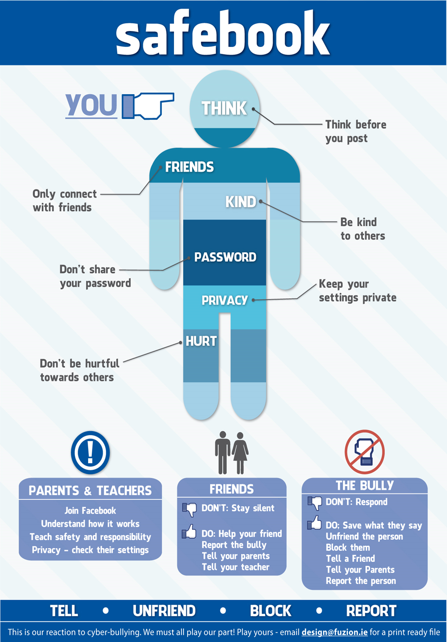

Notes

Notes


For any further information or queries, please phone 0858596628 any time Monday to Friday

