Dear Parents & Pupils,
Just a note to thank you for your efforts over the past few months. The following work is to be completed for the remainder of the school year, including other ideas for enjoyable but educational activities. Hoping to see you all back in September, enjoy the summer and stay safe.
Kind regards,
Fiona & James.

June 8th – June 26th
Reading:  This is one of the most important skills to work on. Use this opportunity to read a wide selection of books. After reading each book, you can then write a review, give your opinion, talk about your favourite character and give a star rating. You may even have a chance to present this in front of an audience in your own home. | Writing:  Free writing - You will be familiar with the concept of “free writing” and may have a special notebook or journal in which you write freely about any topic of your choice, and in any genre. There are a variety of different styles that you can practice:  - Diary writing (personal accounts)  - Recount writing (a report of an event)  - Fiction (short stories)  - Instructional writing (e.g. rules of a game *the children can even come up with a new idea and create their own game!)  - Poetry (Limericks, acrostic poems etc.)  https://storybird.com/member-family-plan (offer a free 7-day trial)  https://www.mystorybook.com/ | Jolly Grammar:  Complete the remaining four sections and accompanying grammar activities. Ask an adult to test your spellings.  English in practice:  Complete any unfinished days or days that you may have missed during the year.

Maths:
Mental Maths:  Complete weeks 35 to 39.  Learn off or familiarise yourself with the maths facts on pages 122 to 127 | Operation Maths:  Chapters 20, 21 & 22 to complete.  Revision 5 – pages 176 and 177- test yourself  Try the maths hunt that will be sent with this document, it’ll be great fun. | Operation Maths Assessment Book:Test yourself -Pages 31 & 32  Tables:  Revise all multiplication & division tables.

Gaeilge:
Bua na cainte Interactive:  Continue with online lessons on the theme  ‘Siopadóireacht’ & corresponding pages in your pupils book. | Bua na cainte upils book:  An Samhradh – pages 195 -200  Dul siar – pages 201 – 204 | *Write your news for the day. (An Nuacht.) Record a video of yourself being a newsreader saying your news.  *Draw a picture of your favourite place. Label as many words that you know in Irish.  *Listen to Irish songs on YouTube and come up with actions to remember them. Would reccomend Gugalaí Gug song

S.E.S.E:
History:  Unit 17 – My School  Read unit 17, answers activities A and B page 87 in your copy or orally with an adult.  Unit 19 -Amelia Earhart  Read unit 19, answers ‘activities’ questions in your copy or orally.  Try one activity of your choice from ‘Get Creative’ p.95  Project work – research the ‘Wright Brothers’ and complete a project on them. | Geography:  See Geography choice board below. | Science  Unit 19 – Light  Read unit 19, answers ‘activities’ questions in your copy or orally.  Try some ‘Investigate’ activities.  *Are objects opaque, translucent or transparent?  *How do concave and convex mirrors work?  *Make a water drop magnifier  *How does a prism work?  Unit 20 – The Living Body  Read unit 20, answers ‘activities’ questions in your copy or orally.  Design & Make – a stethoscope

Geography choice board
First, choose a country. You can pick from a map or a globe. Then, choose three activities to do to make three in a row! You can use websites like BBC bitesize, Dkfindout and National Geographic Kids or books at home to help you.
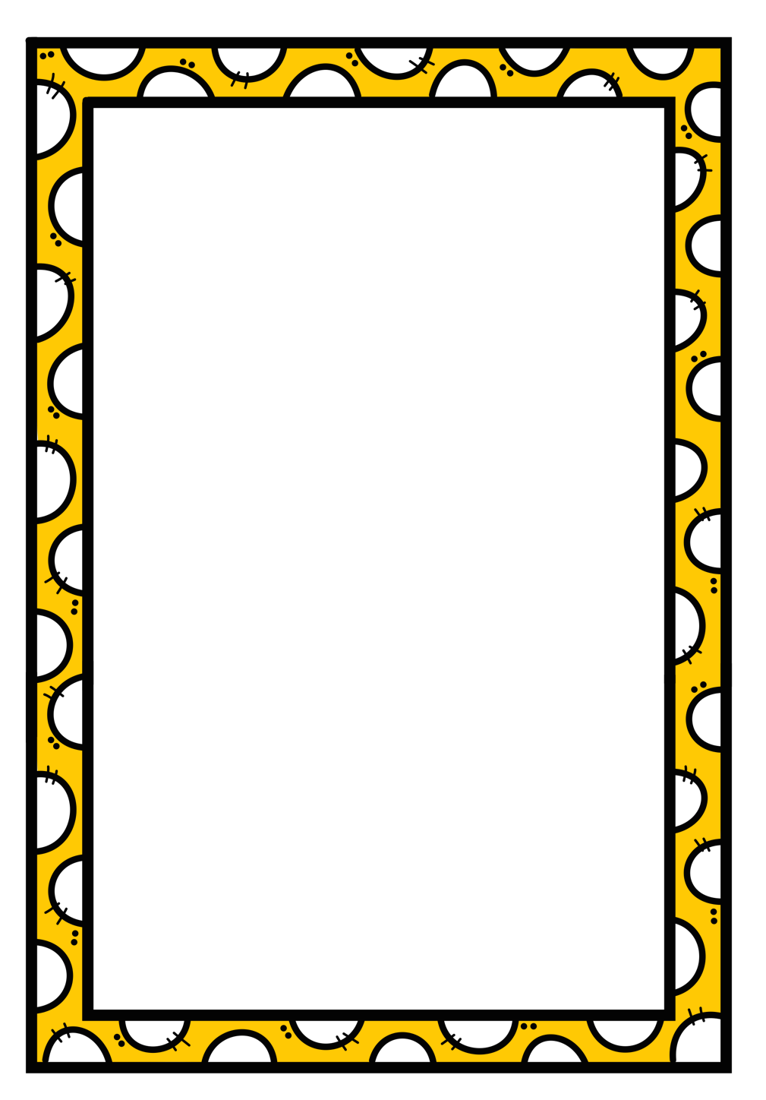

Make a mind map about everything you know about this country. You can break it in food, people, playtime etc. | Make PowerPoint on a computer or an infographic about the most famous places in this country. | Find out what language they speak in this country and learn the sentence: Hello, my name is ____.
Write a sensory poem (using all your senses) about a picture of this country. It could be the city, the countryside or a famous landmark. | Make a list of things that are the same and things that are different between Ireland and this country. | Find out about a famous person from this county and write a report / biography about them.
Find and write a recipe for a traditional food from this county. include pictures if you can. | Write a diary entry for a person your age living in this county. Include food, games, sports and school. | Draw a picture of a myth or story you found out about this country.

Letter writing
Post from a pen-pal and the anticipation of awaiting the arrival of a response may be lost in our global world where social media has taken over the art of writing, but this may be the time to resurrect that magic!
Creative arts
Most homes will have a “bits-and-bobs” box or a bosca somewhere with nets, buttons, lids, wrapping paper etc. Now is a good time to use those recyclables and create a piece of artwork. Children should be encouraged to be original, be creative – and don’t forget to take a picture!
Outdoors / physical activity
There are endless opportunities for physical activity.
- Hopscotch
- Skipping
- Hula-hoops
- Obstacle courses
- Treasure hunts
Local GAA clubs and county teams have been posting videos on their social media outlets with some of their star players demonstrating drills that children can follow.
Nature walks
. It is so important to remember to get active and get outdoors to open spaces.
Incorporate science, geography, oral language, drama and music into a walk whether it’s in a nearby park, along a beach or in the countryside.

Back to basics – other enjoyable, but educational activities
- Board games
- Card games
- Lego
- Jenga
- Jigsaws
- Flying a kite
- Memory games (e.g. stop the clock with one letter of the alphabet and come up with words beginning with a specific letter under certain headings such as boy name; girl name; country / city; food; item of clothing; activity; kitchen utensil etc.)
- Recreate “Countdown” television programme with word puzzles and maths problems.
- Painting

