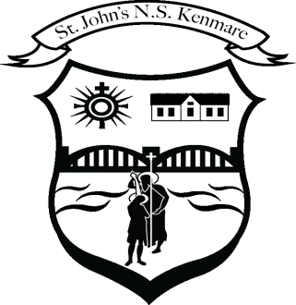
St. John’s N.S., Kenmare
Bunscoil Eoin Naofa, An Neidín
Tel: 064-6642598 / 064-664230
Email info@stjohnskenmare.ie
Web: www.stjohnskenmare.ie

29th May 2020

Dear Parents /Guardians,

I hope I am finding you all safe and well as we approach yet another Holiday Weekend.

The recent announcement that Schools will not re-open until September has brought clarity for families and schools. However, there is much speculation in the media about how this will happen. It is important that we share the most accurate and up to date information with you about the re-opening of schools, how it will happen, when exactly it will happen and the safety precautions which will be in place before any child or staff member returns to school. The guidelines for re-opening schools will be drafted by the Department of Education in consultation with the HSE and all the representative bodies in the educational sector.

Naturally, parents, pupils, school staff and Board of Managements will have many questions and will need absolute assurance that the re-opening of schools can be managed safely.

Our Board of Management supported by the Patron and in consultation with staff and parents will put a specific plan in place for our school. It will be a time for all of us to support each other as we prepare at local level for the completion of this plan.

In the meantime, as in all in schools, the staff in St John’s are continuing to keep your child engaged in their learning using our website and the Seesaw app to set work and communicate with pupils and also to assess their work.

As you are aware, the four days after the Bank Holiday were designated Mid-term break and St John’s National School would have been closed at this time. In this regard, teachers will not be setting homework for children next week. At this stage you all deserve a well earned break and time to enjoy the good weather and the opportunities it will hopefully bring to do some fun outdoor family activities.

From 8th June to 26th June, teachers will be setting a menu of learning activities, many of them fun based which the pupils can engage in over this three week period. This menu will be available on our website from Monday 8th. The Seesaw app will be used to update these activities on a regular basis.

In terms of end of year communication with you, we will be using the newly launched Aladdin Connect App to send you your pupils report card, school calendar for next year, class allocation, book fees as well as updated Department of Education and HSE guidelines.

For our First Communicants and Confirmation candidates and our 62 pupils who are due to graduate from sixth class, it has been a disappointing time with a delay in these key events taking place. Plans however are in place to hold Communion and Confirmation ceremonies in the Autumn when HSE guidelines allow such events to take place.

Regarding the 6th Class graduation, their class teachers are working on a special 0n-line graduation ceremony for now, with planning also in place to hold a celebration for these very special group of pupils in the Autumn, again when such events are permitted.

Finally, we wish you all a safe happy and enjoyable mid-term break and look forward to working with you from June 8th to the school holidays on June 26th which will conclude what has been a most unusual and challenging school year.

As always, Stay Safe and Take Care

Denis Courtney
Principal and Staff

