Hi everybody!
I hope you are good and that you had a lovely weekend. Here is new work for you this week and there will be activities on Seesaw throughout the week too. Hope you are all getting lots of exercise and having fun outside. You are more than welcome to send me your written work on Seesaw if you like, I love to see how you are doing.
Take care,
Mrs Daly :)
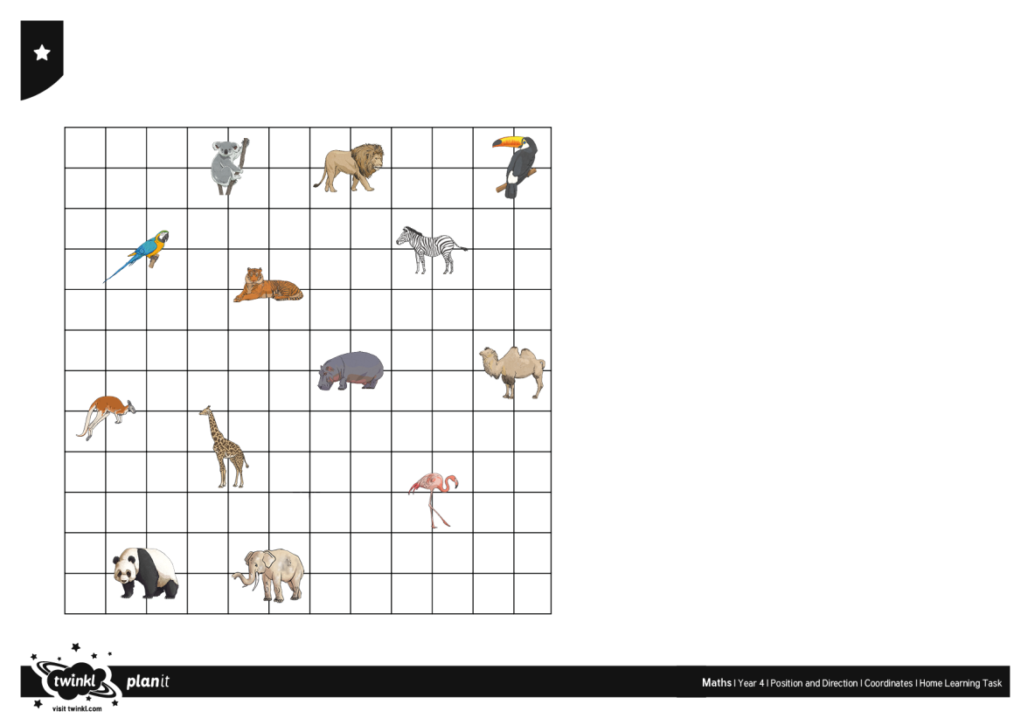
May 25th - May 29th 2020
Maths:
- Mental Maths - 1 block per day
- Practise making amounts of money up to €2 using coins if you have them,
eg. €1.48 = €1 + 20c + 20c + 5c + 2c + 1c
- Challenge - make €2 in a variety of ways eg. €1 + 50c + 20c + 20c + 10c = €2
How many ways did you think of?
- Operation Maths: Money
- Pg 108
- Pg 109
- Online game - https://www.topmarks.co.uk/money/toy-shop-money/eur - click on mixed coins, click on up to €1.
- Tables - https://www.topmarks.co.uk/maths-games/7-11-years/times-tables
- www.mathplayground.com (Maths games)

English
- Jolly Grammar: Complete next unit - Page 64 and 65
- Learn spellings (3 per night)
- Write one sentence for each word into your copy.
- Complete the exercises

- Starlight:
- Read Dr Scorpio Strikes Again (Part 1) on page 62
- Complete the comprehension questions A on page 63

- Writing: Dr Scorpio finds the Zakor gemstone on a meteor - research meteors and asteroids and create a fact web about them.
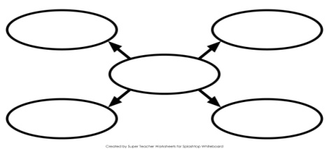
- Poetry:
MAGIC SHOES

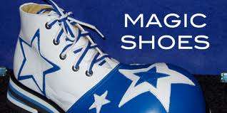

I've got a pair of magic shoes,
they take me to the moon.
Dad says, 'Watch out for rockets,'
and Mum says, 'Come back soon.'

I've got a pair of magic shoes,
they take me to the stars,
and sometimes if I'm early,
I'll stop and have tea on Mars.

I've got a pair of magic shoes,
I can high jump over the school,
I can walk up walls like Spiderman
and act like I'm really cool!

I've got a pair of magic shoes,
I can dance like a disco king,
they spring me up to the rooftops,
they let me do anything.

But what if I had some magic socks,
magic underwear too!
With a magic suit of clothes I'm sure
there'd be nothing I couldn't do.

Brian Moses

- What do you see when you read the poem?
- What would you do or where would you go if you had a pair of magic shoes?
- Look for the words in each verse that rhyme with each other.
- Try writing your own verse for the poem.
- Draw a picture of your favourite image from the poem.

- Oral Language: Tongue twisters can be hard to say but it is funny when we make mistakes. Try saying the tongue twister below. How fast can you say it without making a mistake? Try saying it fast three times!
Tongue twister - 'There's a chipshop in space selling spaceship shaped chips'
You could try making up your own tongue twister or ask your family if they know any.
- Handwriting: Just handwriting (1/2 page per day)
- Reading: Book from home

Gaeilge
- Practise...
- the days of the week - An Luan, An Mháirt, An Chéadaoin, An Déardaoin, An Aoine, An Satharn, An Domhnach (L. 91)
- an aimsir - (L. 91)

Bhí an lá te (hot) /geal (bright) /fuar (cold) /fluich (wet) /gaofar (windy) inné.
(The day was _____________________________ yesterday.)

Tá an lá ____________inniu.
(The day is __________ today.)

Beidh an lá ___________ amárach.
(The day will be _________ tomorrow.)

- Bua na Cainte workbook - An Teilifís

- An Nuacht - L 91

- Use this link to watch the story 'An Giorria agus an Toirtís'. https://www.youtube.com/watch?v=U0K2QwfpWaM

- Dathaigh an pictiúr de réir uimhreacha (Colour the picture by numbers) L 92

Bua na Cainte is available to download. If you would like to download it, the username is 'trial' and the password is 'trial'.

Religion
Parents can gain access to Grow in Love using
Email address: trial@growinlove.ie Password: growinlove
https://app.growinlove.ie/en/user/lesson-resources/194

Theme 9 - 'Creation'
- Lesson 2: 'God wants us to be happy'
- Watch the videos on the veritas website of 'What God wants' and 'Adam and Eve'.
- Complete page 52 of the workbook - Adam and Eve.
- Say the prayer 'Glory be to the Father' (Page 51).
- Say the prayer of thanksgiving that you wrote on page 51.

- May is the month when we honour Holy Mary and pray the Hail Mary.

SESE
- Folens Explorers Book (Page 68 and 69)
- Read 'What do people around the world wear to celebrate?' Pg 68
- Answer questions A, B and C Pg 69
- On RTE Home School Hub, Múinteoir Ray was teaching everyone about gravity and he tested it through use of paper airplanes. Here is the link so you can watch it. https://www.rte.ie/player/series/1st-and-2nd-class-rt%C3%A9-home-school-hub/SI0000006858?epguid=PL000003418
- There is information about The Wright Brothers and the first successful airplane in this link https://www.rte.ie/learn/2020/0519/1139280-1st-2nd-class-science-paper-airplanes/ along with questions. It also shows you how to make paper airplanes.

Wellness and Exercise

- Cosmic kids yoga - search online
- Joe Wicks (The Body Coach) is live on YouTube every morning or can be watched at anytime during the day

Music
- https://www.youtube.com/watch?v=mnTaAoWs-Mo
This is 'The Planets Song' - You could learn the chorus and sing along.

