Hello everyone!
I hope you are all keeping safe and well, and enjoyed your weekend. I have added some new work for you here on the website and there will be activities on Seesaw throughout the week too. Don't feel under pressure to get everything done, look after your well-being, get lots of exercise and have fun. The children can also send me some of their written work on Seesaw if they would like to.
Take care,
Mrs Daly :)

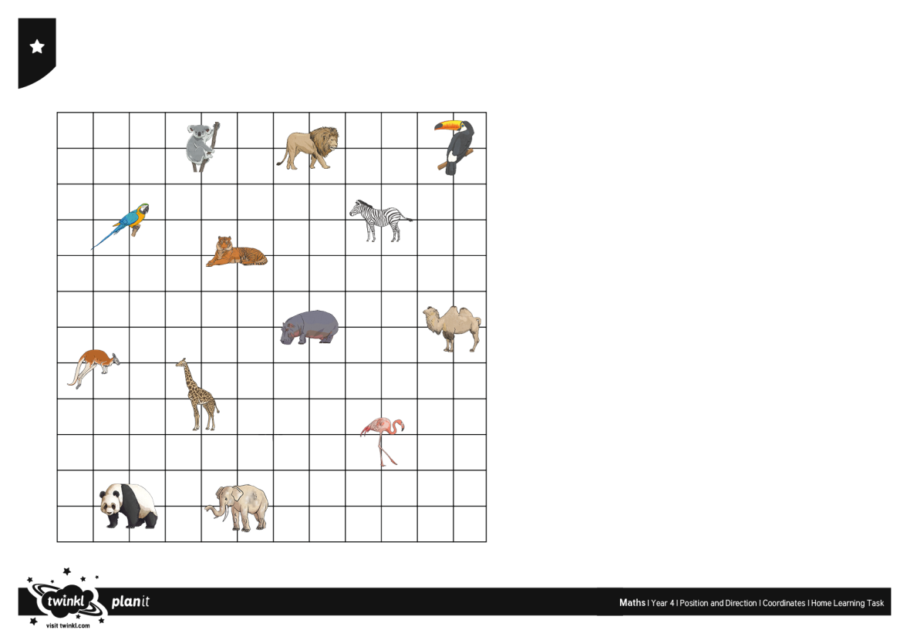
May 18th - May 22nd 2020
Maths:
- Mental Maths - 1 block per day
- Watch this clip about spatial awareness and direction
https://www.rte.ie/player/series/1st-and-2nd-class-rt%C3%A9-home-school-hub/SI0000006858?epguid=PL000003397

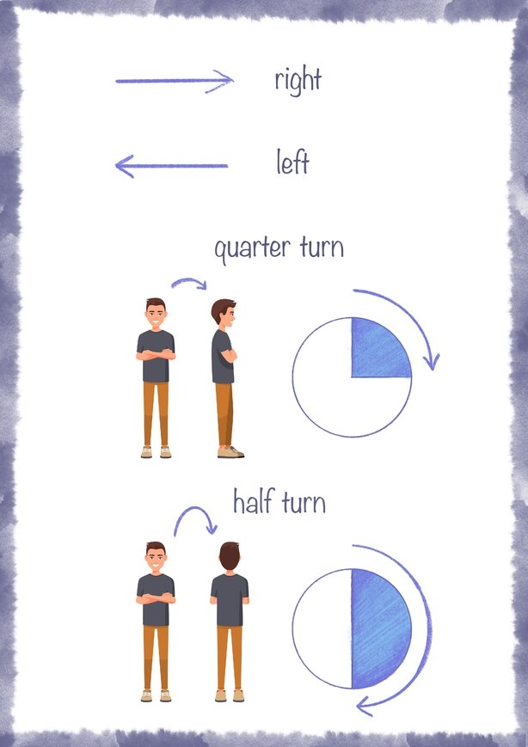

- Operation Maths:
- Pg 102 Angles
- Pg 103 Direction

- https://www.topmarks.co.uk/maths-games/7-11-years/times-tables (Maths games)
- www.mathplayground.com (Maths games)

English
- Jolly Grammar: Complete next unit - Page 62 and 63
- Learn spellings (3 per night)
- Write one sentence for each word into your copy.
- Complete the exercises

- Writing:
Story writing - Title 'Going to the Zoo'
Think back to when we learned about recount genre when writing your story.
Who went with you? When did you go? Where did you go? What happened?
What animals did you see? What was the weather like? Did you see the zookeeper?
Try to include words such as, First... Then... Next... After that... Later... Finally...
Write the heading and then your story.
Check your spellings.
Draw a picture

- Oral Language:
Interview a family member. Ask them about their favourite things and why they like them. You could brainstorm what questions you are going to ask them before you start, eg. What is your favourite food/colour/song? Why do you like it?
Maybe somebody in your family could interview you too!

- Handwriting: Just handwriting (1/2 page per day)
- Reading: Book from home

Gaeilge
- Bua na Cainte workbook
- An Teilifís
- Cén t-am é? L. 88
- Tarraing an t-am L. 88
- leis/léi L. 89
- Léigh an scéal L. 90

Bua na Cainte is available to download. If you would like to download it, the username is 'trial' and the password is 'trial'.

Religion
Parents can gain access to Grow in Love using
Email address: trial@growinlove.ie Password: growinlove
https://app.growinlove.ie/en/user/lesson-resources/194

Theme 9 - 'Creation'
- Lesson 1: 'God created us'
- Watch the videos on the veritas website
- Complete page 50 and 51 of the workbook - Gifts and talents
- Say the prayer 'Glory be to the Father'

- May is the month when we honour Holy Mary and pray the Hail Mary.

SESE
- Country Factfile: Paddington Bear is said to be from 'Darkest Peru'. Create a fact poster with information all about Peru. Don't forget to add things like: Location, Capital city, Language, Currency, Population, etc. You can add it to your journal on Thursday May 21st.
- Here is an experiment about dissolving that you could try at home, record your findings https://www.youtube.com/watch?v=e-2EoyDYamg

Wellness and Exercise

- Cosmic kids yoga - search online
- Joe Wicks (The Body Coach) is live on YouTube every morning or can be watched at anytime during the day

Music

Here is the link to The Bare Necessities from The Jungle Book https://www.youtube.com/watch?v=9ogQ0uge06o

- Listen to the music in the YouTube video above
-What does the music make you think of?
-What instruments do you hear?
-Is there more than one voice?
-Do you hear any dramatic changes in the music?
-Is the music loud or quiet?

