NEWSLETTER – December 2019

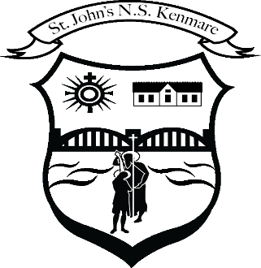
St. John’s N.S. Kenmare
Bunscoil Eoin Naofa An Neidín
Tel: 064-6642598 / 064-6642300
e-mail: info@stjohnskenmare.ie
web: www.stjohnskenmare.ie

Upcoming School Closings:
Closing: Friday, December 20th for Christmas Holidays at
11.45 a.m. for Infant pupils and 12 noon for pupils from 1st to 6th Class.
Re-opening: Monday, January 6th 2020 at 9.20 a.m.
Closed: Friday, January 24th for Teacher in-service.
Closed: Thursday, February 20th and Friday, February 21st – Mid-term break.
Closed: Monday, February 24th – Teachers in-service.

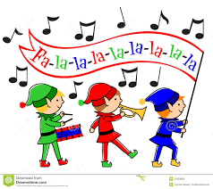
Christmas Performances:
Christmas presentations for Classes First and Second will take place Thursday, December 12th at 10.30a.m. and for Classes Junior Infants and Senior Infants at 11.30a.m. in School Hall.
Christmas Carol Services will be presented in Holy Cross Church, Kenmare for pupils from Third to Sixth Classes on Tuesday, December 17th at 1.00p.m.
All are welcome to attend.

Carol Singing:
Please support Carol singers from St. John’s N.S. who will perform a medley of Christmas favourites on
Thursday, December 19th in SuperValu, Kenmare.
Ms. O’Sullivans Third, Mr. Devane’s Fourth and Mr. Hussey’s Fifth Classes will perform from 12.45p.m. – 1.30p.m.
Mrs. Lucey’s Third, Ms. Carol O’Sullivan’s Fourth and Ms. Spillane’s Fifth Classes will perform from 1.45p.m. – 2.30p.m.
All proceeds collected will be donated to Cork Simon Community. Carol singing entertainment will also be provided for Kenmare Community Hospital and Taobh Linn on Wednesday, December 18th.

Parents Association:
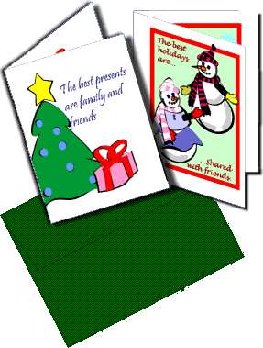
The Parents Association are currently distributing pupil designed Christmas Cards which they have organised throughout the school.
Well done on all the hard work to the committee.
The Parents Association have also organised for Santa to visit all our classrooms on Thursday, December 19th.
The Association also want to invite all parents to an open meeting with the Parents Association Committee at 8p.m. on Thursday, January 16th in the School Hall.

Christmas Jumper Day:
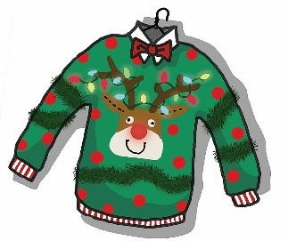
Friday, December 20th is designated as non-uniform Day when instead of uniform pupils can wear a Christmas Jumper, T-shirt or Christmas colours.
By wearing your festive wear to school, you can help support the local St. Vincent de Paul so please support this worthy cause by giving €2 to class teacher on December 20th.

Junior Entrepreneur / Bizz World:
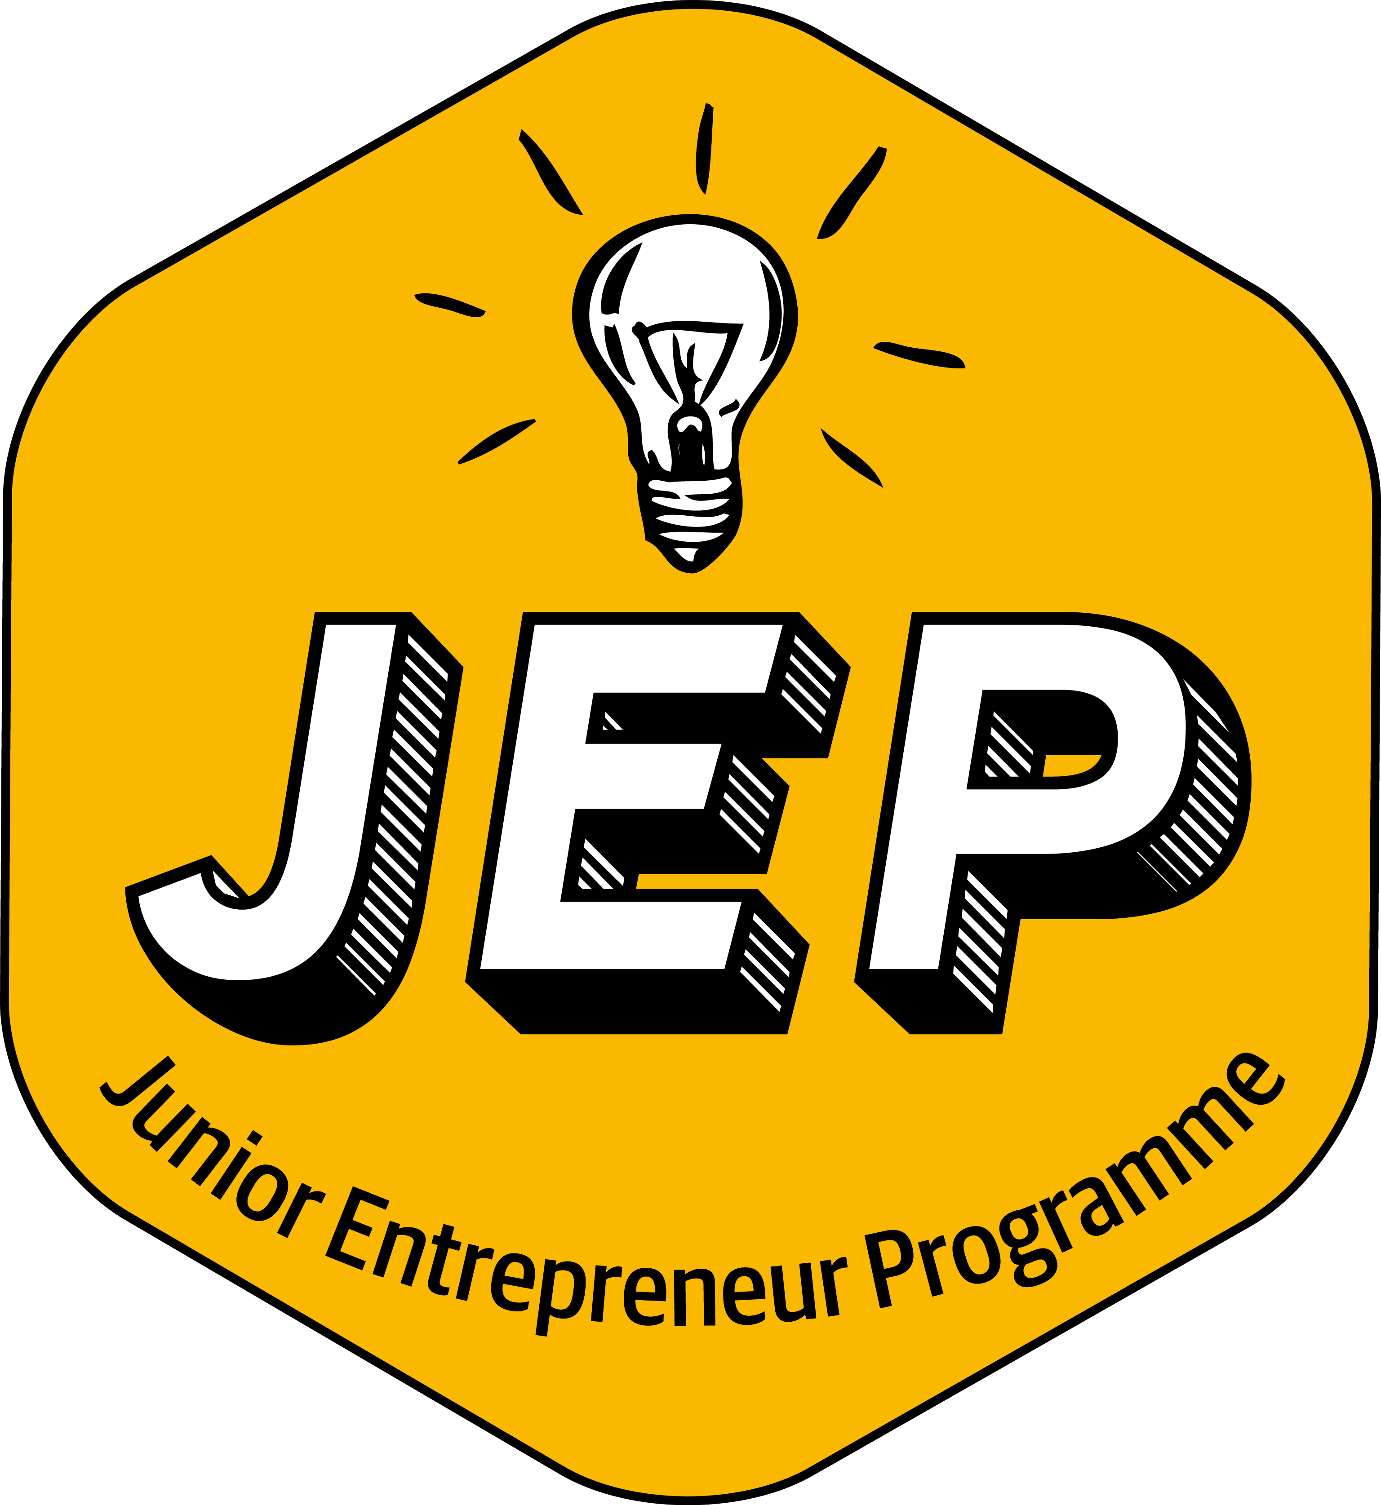
Pupils from both Sixth Classes will be participating in the Bizz World Entrepreneur programme on Wednesday, December 18th and Thursday, December 19th. Kerry footballer Shane Enright will facilitate the programme with the classes. The primary activity will be a Dragons Den style presentation from groups within both classes.

Appointments:
Congratulations to Mr. Tadhg Morley on his appointment as Permanent Teacher in St. John’s N.S. Tadhg is currently teaching Sixth Class.
Maternity leave vacancies in the school have been filled as follows,
Ms. Brid Costello will replace Mrs. Mona Cremin in Junior Infants, Mrs. Mairead Daly will replace Ms. Joanne Cashman in Second Class and Mr. Patrick Mannix will replace Ms. Grace Healy in Sixth Class.

Arts Grant:
St. John’s N.S. were lucky enough to be awarded an Arts Grant in conjunction with Tralee Education Centre and Kerry County Council.
The grant was used to finance a Teacher, Artists Partnership (TAP) in the school.
Artist Andrew Scattergood worked with Ms. Spillane’s Fifth Class in an arts programme combining the theme of Climate Change, Green Schools art and drama.
The end result of the initiative was the presentation of an Arts and Drama production which was entitled ‘What’s the Kraken’.
The presentation took place in the school on Friday last December 6th for pupils of the school and parents of Ms. Spillane’s Fifth Class.
Sincere thanks to Artist Andrew and class teacher Ms. Spillane for all their hard work on making the Programme a huge success.

Cumann na mBunscoil Winners:
The boys’ football team continued their winning ways by emerging victorious in the final in Division 1 of the schools Cumann na mBunscoil competition against Holy Family School, Rathmore.
The victory added to the celebration of their fantastic win against Schoil Mhuire, Killorglin in Division 1.

On behalf of all the staff and pupils of St. John’s N.S. we would like to wish you a Happy, Holy and Peaceful Christmas and New Year.

Many thanks for your co-operation during 2019.

____________________
Denis Courtney,
Principal & Staff.

