# NEWSLETTER – October 2019



**St. John’s N.S., Kenmare**

**Bunscoil Eoin Naofa, An Neidín**

**Tel: 064-6642598 / 064-6642300**

**e-mail:** [**info@stjohnskenmare.ie**](mailto:info@stjohnskenmare.ie)

**web: www.stjohnskenmare.ie**

**Upcoming School Closings:**

Closed: Monday, 28th Oct. 2019 to Friday, 1st Nov. 2019 – Mid-Term Break

**Halloween Dress up Day:**

[](http://www.google.ie/imgres?imgurl=http://bayswatertennis.com/wp-content/uploads/2009/10/halloween_clip_art_3.jpg&imgrefurl=http://bayswatertennis.com/archives/halloween-wine-cheese-tasting-night/&usg=__YJHm5RKLz4y6RYQQ5090Lb2COMI=&h=268&w=289&sz=21&hl=en&start=16&zoom=1&um=1&itbs=1&tbnid=5amR6eCTfUvomM:&tbnh=107&tbnw=115&prev=/images?q%3Dhalloween%2Bimages%2Bclip%2Bart%26um%3D1%26hl%3Den%26safe%3Dactive%26sa%3DN%26rlz%3D1W1RNWE_en%26ndsp%3D20%26tbs%3Disch:1)As is traditional to celebrate Halloween the children are being given the option of dressing up in their Halloween costume on Friday, October 25th. Prizes will be given in each class grouping for the best costume with preference being given to costumes which are home-made.

All pupils are asked to bring in €2 on the day which will be donated to Brú Columbanus which provides accommodation to relatives of patients in Cork hospital including the hospice and especially to relatives of sick children.

**Celtic Travelling Books (Book Fair):**

Sincere thanks to all the parents and children who helped to make our Book Fair such a successful event. We are delighted to announce we raised €5,398.00. Not alone did this event assist in promoting reading in the school but we will also receive book rewards to the value of €3,238.60.

Each class will benefit by adding new books to their class library. We really appreciate all your support and contributions. Many thanks again and happy reading. Sincere thanks also to the Book Fair co-ordinator Mrs. Fiona O’Mahony for all her hard work in organising this great school event.

**Dates for your Diary:**

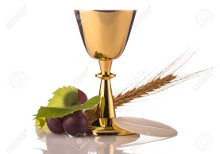Confirmation will take place in Holy Cross Church, Kenmare on Tuesday, March 24th 2020 at 3.30 p.m.

First Communion will take place in Holy Cross Church, Kenmare on Saturday, May 9th at 2020 at 10.30 a.m.

**Climate Change Workshops:**

As part of Green Schools Climate Action Week, students in 3rd to 6th class participated in a Climate Action Workshop and discussed what changes they can make in their home and school lives to help support possible climate action. All students’ lunch waste was collected and students are being asked to go plastic and waste free in their lunch boxes.

**Team Hope Shoebox Appeal:**

Leaflets are being distributed to pupils from 1st to 6th class encouraging them to send a Christmas Shoebox to a child struggling in poverty or with the effects of conflict in Eastern Europe, Africa and the Middle East. In the coming days pupils will also be shown a DVD giving information on what items can be put in the boxes. The deadline for return of the shoeboxes is Friday, November 8th.

**Retirement:**

Tá Máistir Ó Súilleabháin ag éirí as!

We want to wish all the best for a long and happy retirement to teacher, Danny O’Sullivan, who is retiring on Friday, October 25th. Danny spent over 20 years teaching in Cork City – 12 years in The Cathedral N.S. and 10 years in Strawberry Hill N.S. – before returning to his native Kenmare. In September 1999, he joined the staff of St. Francis’ Boys N.S. and in 2012 moved to the newly built Bunscoil Eoin Naofa/St. John’s N.S. where he taught up to the present day. As a dedicated, talented teacher, Danny’s contribution to the education and welfare of the hundreds of pupils whose lives he touched over the years has been outstanding. As his colleagues, we will miss him dearly but will cherish many happy memories of his time with us. Ní bheidh a leithéid arís ann!

Slán agus go n-éirí leat, a Mháistir.

**Parents Association:**

At the AGM of the Parents Association before school closed for the summer holiday, the Parents Association were delighted to welcome many new members to the Committee.

Committee is as follows: Chairperson, Mary Murphy, Vice Chairperson, Jennifer Downing, Secretary, Susan O’Shea, Treasurer, Natalie Moriarty, PRO, Charlotte O’Neill. Other members are, Maire O’Sullivan, Deirdre Sweeney, Libby O’Sullivan, Cliona Lehane, Tracey Collins, and Sheila O’Sullivan.

On November 14th at 7.30 p.m. at the school, there will be an Information Session delivered by a representative from the National Parents Council on the role and function of the Parent Association. This is open to the whole school community and gives everyone a better understanding of what a Parent Association is and does within the school.

Parents can keep up to date with the PA by following the Facebook page:

<https://www.facebook.com/stjohnsnspa/>

The PA is affiliated to the National Parents Council. For information and resources see www.npc.ie.

**WE WOULD LIKE TO WISH ALL OUR PUPILS AND PARENTS**

**A VERY HAPPY AND SAFE HALLOWEEN**

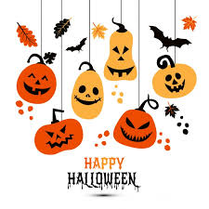

Mise le meas,

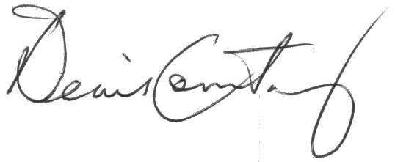

Denis Courtney,

Principal and Staff.